Design of a small satellite UHF radio beacon for Identification, Telemetry, Tracking and Control

Travis J McKee[1]

*The University of New South Wales at the Australian Defence Force Academy*

The reduced cost of designing, manufacturing, launching and operating small satellites has seen a significant increase in the number of objects deployed into the low earth orbit space environment. Small satellites operated by organizations with little space experience has resulted in a large failure rate, increasing the number of space debris and creating more reliance on expensive space monitoring equipment to maintain space situational awareness. The aim of this study is to provide a concept design for a self-sustained satellite radio beacon that can transmit a unique identification and telemetry data, independent of any satellite system failures, to multiple dispersed ground stations which allows for tracking of the satellites position through trilateration. The satellite radio beacon system allows for: 1) the collection of telemetry data for fault analysis which could decrease the current satellite failure rate; and, 2) a radio signal for tracking using cost-effective ground stations irrespective of satellite system failures to reduce the reliance on space monitoring equipment. The study will utilize an agile, iterative design approach in which each component of the small satellite UHF radio beacon system (satellite radio beacon, communications link and ground receiving station) will be designed, tested and verified in sequential order. This study has produced a solderless breadboard prototype design for the satellite radio beacon that is capable of self-sustained operation in a ground environment. The communications link, using a LoRa radio module, is capable of the reliable transmission of data for the distances expected for a small satellite in a low earth orbit. The ground receiving station has proven the capability to receive the identification data, telemetry data and transmit a command for satellite control. Further work is required to reduce the uncertainty in the time measurement techniques by the ground receiving station to create an accurate tracking capability which would allow the continued development of the satellite UHF radio beacon system.

# Contents

1. Introduction 3
2. Aim 3
3. Background 4
4. The present study 4
5. Satellite radio beacon segment 4
   * + 1. Materials and methods 5
       2. Results 5
       3. Discussion 6
   1. Communications link 7
      * 1. Materials and methods 8
        2. Results 8
        3. Discussion 9
   2. Ground receiving segment 10
      * 1. Materials and methods 10
        2. Results 11
        3. Discussion 11
6. Conclusion 12
7. Recommendations 12
8. Acknowledgements 13

References 14

APPENDICES

Appendix A. Arduino Pro Mini processor testing method and results A1

Appendix B. RFM96 LoRa radio module testing method and results B1

Appendix C. Satellite radio beacons software flow chart and design considerations C1

Appendix D. Satellite beacon electrical power regulation testing method and results D1

Appendix E. Total beacon electrical power requirements and generation testing method and results E1

Appendix F. Satellite beacon electrical power storage testing method and results F1

Appendix G. Communication link testing method and results G1

Appendix H. Communication link budget calculations H1

Appendix I. Ground receiving station software flow chart J1

Appendix J. Ground receiving station time measurement error investigation, testing and results K1

Appendix K. Ground receiving station final verification testing method and results L1

# Nomenclature

*Terms, Abbreviations and Acronyms:*

ACMA = Australian communications and media authority

APM = Arduino pro mini

BW = Bandwidth

CR = Coding rate

CRC = Cyclic redundancy check

EEPROM = Electrically erasable programmable read-only memory

EIRP = Effective isotropic radiated power

FPGA = Field-programmable gate array

FSPL = Free-space path loss

GNSS = Global navigation satellite system

IDE = Integrated development environment

ISR = Interrupt service routine

ITU = International telecommunication union

LDO = Low dropout

LED= Light emitting diode

LEO = Low earth orbit

LPWAN = Low-power wide area network

NB-IoT = Narrowband – Internet of things

PPS = Pulse per second

RF= Radio frequency

RTL-SDR = Realtek - software defined radio

RX = Receive

SDR = Software defined radio

SF = Spreading factor

SMA = SubMiniature version a connector

SRAM = Static random access memory

SSA = Space situational awareness

TDOA = Time difference of arrival

TT&C = Telemetry, tracking and control

TX = Transmit

UART = Universal asynchronous receiver-transmitter

UHF = Ultra high frequency

USB = Universal serial bus

UTC = Coordinated universal time

# Introduction

The reduction in economic and resource cost of designing, manufacturing, and launching a small satellite has led to an increased number of small satellites being operated in the Low Earth Orbit (LEO) space environment[2]. A greater number of objects in the LEO environment has resulted in new challenges for space situational awareness (SSA) and has led to a larger reliance on resource expensive space monitoring equipment to maintain situational awareness in the LEO environment. The reduced cost of launching a small satellite into the LEO environment is a result of releasing multiple small satellites from a single launch platform, this is commonly known as ride sharing. Ride sharing has resulted in upwards of 100 small satellites being released from the same launch vehicle in a small-time frame[3]. This has resulted in a reduction in SSA immediately after the launch of small satellites and throughout their operational life cycle due to difficulties in identifying individual satellites. The difficulties of identifying small satellites in the LEO space environment results in a greater demand on the limited ground-based optical and radar monitoring resources to maintain an SSA capability. The standardisation of small satellite manufacture has reduced the cost of production allowing government, educational and commercial organisations with little to no space mission experience to create and produce small satellite designs. The unique development and design process to meet the organisation requirements for each satellite has resulted in a 55% failure rate for academic institutions and a 23% failure rate for commercial industry[4]. The cause of a small satellite failure is difficult to determine as the failure can reduce the quantity of satellite telemetry data available for fault-finding. A deficiency of telemetry data can result in the determination of satellite failure being contributed to several causes of possible failure (typically 5-10 possible causes). The ride sharing launch produces additional difficulties in identifying an individual satellite immediately after release by the ground monitoring stations which leads to an increase in failure rates due to difficulties in creating the initial communication link with the individual satellite[5]. A satellite failure can result in the satellite becoming uncontrollable and/or difficult to track causing it to become a space debris object leading to an increased risk of a collision with other objects within the LEO space environment.

To reduce the small satellite failure rate, increase SSA in the LEO environment and reduce the reliance on space monitoring equipment a solution needs to be investigated that aims to provide better methods of obtaining satellite identification and telemetry data and provide a cost-effective method of tracking space debris, active and end of life satellites in the LEO space environment.

The purpose of this project will be to design a self-sufficient, independent satellite radio beacon system that can transmit satellite identification and telemetry data and receive control commands using a UHF radio signal that can be tracked using multiple geographically dispersed, cost-effective ground receiving stations.

The satellite radio beacon shall primarily allow for the identification of an individual satellite after launch and its operational life cycle providing greater SSA which leads to a lower risk of collisions in the LEO environment. Multiple graphically dispersed ground mounting stations constructed using low-cost, commercially available components are to be utilised to track the satellite via the beacon radio signal allowing the existing space monitoring systems to focus on other LEO space objects. The beacon will have a secondary function that can provide telemetry data for satellite on-orbit fault finding to facilitate the determination of causes of failure. Determining the actual cause of failure as opposed to having several possible causes of failure is expected to reduce the number of failures in future launches and operations. This system can be extended to include an alternative communications pathway that can be used to provide limited control of the other satellite systems to offer a redundancy system to correct on-orbit failures. Correcting an on-orbit failure can result in regaining control of the small satellite reducing the number of space debris objects in the LEO environment.

# Aim

The aim of this project is to design and produce a ground-tested satellite UHF radio beacon prototype and a cost-effective ground monitoring station prototype that can sustain a communications link for the distances required of a satellite in LEO. In order to achieve this aim, three aspects will be investigated, firstly the satellite radio beacon that is to be a self-sustained UHF communication system capable of operating independently of all other satellite systems for the duration of the satellites operation mission (until deorbit). Secondly, the UHF communications link which must be able to support the reliable transmission of satellite identification and telemetry data up to 2000kms to support the operation and monitoring of satellites in the LEO space environment. Finally, the ground monitoring station which must be capable of capturing the satellites identification data, telemetry data, recording the precise time of arrival of the radio signal and determining its own global location. The ground station will be able to pass on the captured data and measurements to a peripheral device for post processing using the time difference of arrival (TDOA) calculation technique to determine the position of the satellite through trilateration.

# Background

The theory of operation of the satellite beacon system is that the system contains its own power, processing and radio systems to ensure that it is self-contained and independent of the other satellite systems. Each radio beacon system contains an identifier in the form of a 16-bit address which allows for 65,536 unique addresses to be used simultaneously. Each radio beacon processor has the capability to be linked to other systems within the satellite to allow for the collection of satellite telemetry and health data or to pass a received command to another system. The 16-bit identification address and collected telemetry data are sent via the beacon radio to a ground receiving station to uniquely identify the small satellite and provide satellite telemetry data for tracking and fault-finding purposes. The radio beacon system can receive data from a ground receiving station to provide control of the beacon system and emergency control of the small satellite.

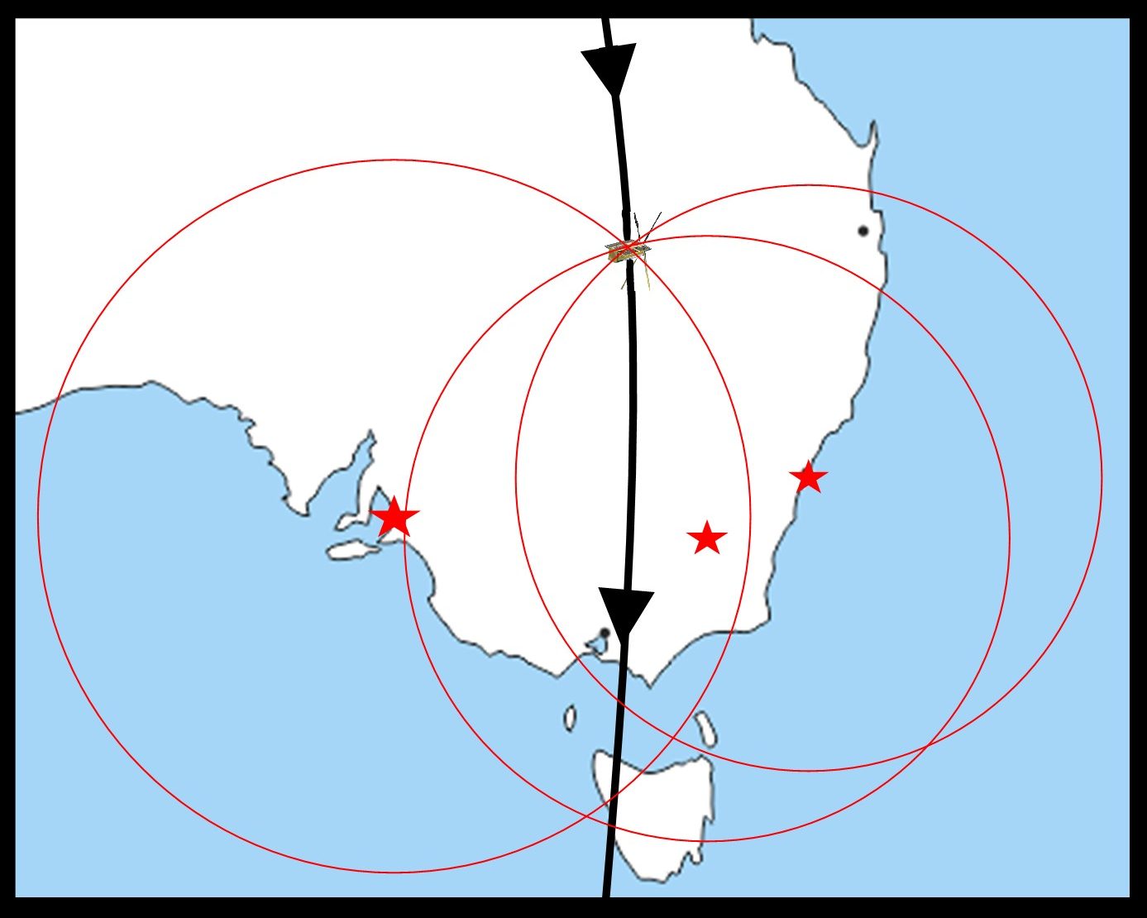The ground station can receive and process the identification and telemetry data as well as providing a precise time of arrival of the received signal. The precise time of arrival for a unique small satellite beacon signal being received at three globally dispersed ground receiving stations allows the position of the satellite to be calculated. The global position of each ground station must be known with each station being synchronized to the same clock timing to allow for the TDOA calculation technique to approximate the satellites position as shown in Figure 1 (see right). The trilateration of position from three stations reduces the possible position of the satellite to two spatial locations with one being discarded as unfeasible due to it being below the surface of the earth. The uncertainty in the position of the satellite decreases as the number of ground stations used in the TDOA calculation increases.

Figure 1 - Visual representation of TDOA trilateration with 3 stations

A review of the current systems available has shown that solutions are provided for individual aspects of SSA in the LEO environment, but they do not take a holistic approach to the key parameters of a satellite telemetry, tracking and control (TT&C) system which includes satellite identification. There are several systems available that provide identification (CUBIT[6], SOARS, Passive RF tag[7], ELROI[8] and LEDSAT[9]) or telemetry (safety radio beacon[10]) and some which provide identification and telemetry (HyELT, RILDOS[11] and IRASAT1[12]). The existing systems deliver solutions for one or two parameters of the TT&C system which address either, but not both problems highlighted in the introduction. The proposed satellite radio beacon system will implement solutions for all four key parameters of a TT&C system that will address both identified problems.

The major orbital parameters that will be used for this project are based on a generic small satellite mission in the LEO environment. The most common orbits for a small satellite mission are sun-synchronous with an orbital height of 300-400kms and inclination of 52° or an orbital height of 500-800kms and inclination of 98°[13] with the later parameters used for the testing of this system. The orbital parameters used for testing results in an orbital period of roughly 90 minutes with the view window of each pass being in the vicinity of 8-10 minutes in which the satellite and ground station have a slant range of between 500kms to 2000kms.

A key goal of this project is to ensure that the design of the ground monitoring station can be carried out such that the costs, difficulty of construction and the difficulty in operating the equipment is minimized. The result of minimizing these aspects of the design will allow a broader spectrum of the public, particularly the growing space enthusiast community, to create their own ground monitoring stations. This allows a larger number of ground stations that are more geographically dispersed which has a two-fold effect of increasing the footprint and tracking reliability of the ground stations and increasing the public awareness and engagement.

# The present study

The design of the satellite radio beacon system will be broken up into three major components: the satellite radio beacon, the communication link and the ground receiving station. The satellite radio beacon contains three sub-system: (1) Computer processing, (2) Radio transceiver, and (3) Power generation, storage, and regulation. The communications link is a standalone component while the ground receiving station will be separated into three sub-systems: (1) Computer processing, (2) Radio transceiver, and (3) GNSS module.

## Satellite Radio Beacon

The first component of the system to be investigated is the feasibility of a satellite radio beacon that is a self-sustaining system and independent of all other satellite systems. The beacon must contain its own processor, radio and power generation, storage and regulation system to ensure it is self-sustained and can continue independent operation if there is a failure in another satellite system. The major constraint for the design is that the electrical power generated can meet the electrical requirements of each sub-system. The components used in each sub-system will be selected to ensure self-sufficiency, independence, cost-efficiency, ease of operation and minimization of size and weight.

### **Materials and Methods**

The first decision in the design process was to select the components for the initial design of the radio beacon with the focus being on components that have low power consumption and can meet the requirements of each sub-system. The solutions researched for the processor were a Teensy based microcontroller, an Arduino based microcontroller, a raspberry Pi and using a FPGA board with the 3.3V, 8MHz Arduino Pro Mini module (APM) using a ATMEGA328P[14] processor being selected for the initial design. The APM was selected as it fit all the requirements of the processor system, it has a proven space heritage, it is well resourced and can be operated with a low supply voltage and clock speed to reduce power consumption. The APM module contains an in-built power regulation system using a Low Dropout (LDO) voltage regulator which will be used in the initial design. Three radio systems that are capable of long-range communications were found during the initial investigation for the radio design solution: The LoRa spread spectrum system, SIGFOX Low-Power Wide Area Network (LPWAN) system and the NB-IoT LPWAN system. The LoRa radio system[15] was the selected medium for the initial design for it provided a superior point-to-point communications protocol, high immunity to noise and doppler shift, greater software support and can operate in the 70cm (430MHz, RFM96 module) and 33cm (915MHz, RFM95 module) band radio spectrum. A LoRa module breakout board designed by Boyan Nedkov[16] was used to allow for compatibility with a prototyping solderless breadboard. Solar power was the only system considered for the power generation system due to the difficulties of operating other power sources (Lithium-ion batteries, hydrogen fuels cells, nuclear power, thermo-photovoltaic cells, etc.) in a space environment. The solar panel selected for ground testing is a 0.5W, monocrystalline Silicon panel from Seeed[17] which has a typical output of 5.5V with a current of 100mA at 17% solar conversion efficiency. A capacitor-based energy storage system was selected for the initial design due to the launch isolation and ground testing requirements of a battery-based system.

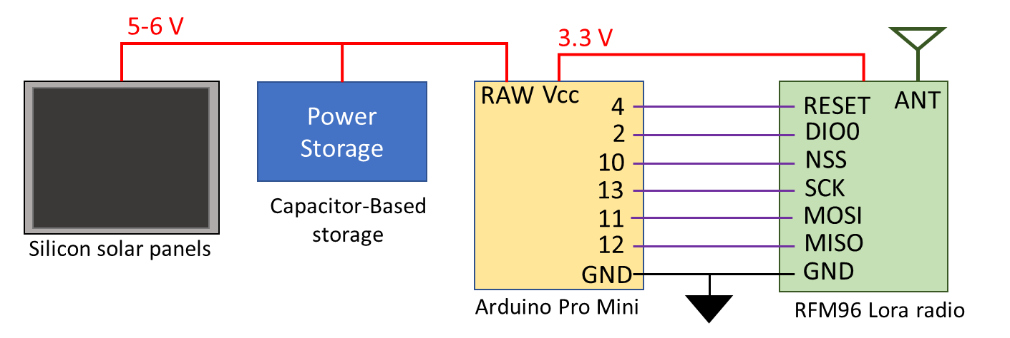The initial design of the satellite radio beacon system was constructed on a prototyping breadboard (refer Figure 2 to the left) using Arduino IDE[18] software to operate the APM module with the LoRa radio module being driven by the Radiohead library developed by Airspayce[19]. To ensure that the beacon can meet the self-sufficient and independent requirements, the initial focus of the testing was to minimize the current consumption of the beacon sub-systems to reduce the number and size of solar panels required. The first set of tests carried out were to support the investigation of minimizing the current consumption of the processing sub-system (APM module) with the testing method and results detailed in Appendix A. The next investigation was to determine methods of minimizing the current consumption of the LoRa radio module which is supported by the testing method and results shown in Appendix B. The next step in the design process was to develop the software that will be utilised in the satellite radio beacon which is based upon the software flow chart and design considerations in Appendix C. The final investigation for current consumption minimization was carried out on the power regulation system with the testing method and results presented in Appendix D. At the conclusion of the current minimization investigation, testing was carried out to determine the total current requirements of the beacon system and methods to reduce the number solar panels required for the successful operation of the satellite radio beacon system which is set out in Appendix E. The final investigation of the beacon design was to develop the electrical power storage sub-system with the testing method and results shown in Appendix F.

Figure 2 - Satellite radio beacon prototype design for initial testing

### **Results**

Table 1 - Average current consumption for the APM module processor and built-in regulator



A summary of the results from testing the APM module is shown above in Table 1 with the results indicating a higher than expected current measurement for the ATMEGA32P processor by 10mA for all modes, which is attributed to a green LED that constantly consumes 10mA when power is applied. The results show a significant increase in the APM current consumption if the supply input voltage is increased from 3.3V to 5V. The current consumed by the APM module is shown to be reduced when utilising the power saving modes of the *LowPower* library with the largest reduction occurring when the *powerDown* or *powerSave* modes are used.

Table 2 - RFM96 LoRa module average current consumption for each mode of operation



The results for testing the current consumption of each mode of operation for the LoRa radio module is summarized above in Table 2 and the results show that the RFM96 LoRa module consumes the smallest amount of current when it is in *sleep* mode and the largest in the *receive* mode (unless radio packets are being transmitted).



Figure 3 - RFM96 module current consumption for TX power level and transmission time for radio packet size results

The results of the current consumption measurements detailed above in Figure 3 shows the LoRa module current increases linearly (4.5mA/dBm) as the TX power increases until 17dBm is reached in which it plateaus at 117mA. The results indicate that the transmission time increases linearly by 10ms when the radio packet size increases by 5 bytes when using the (0) default RadioHead radio settings (medium data rate and range).

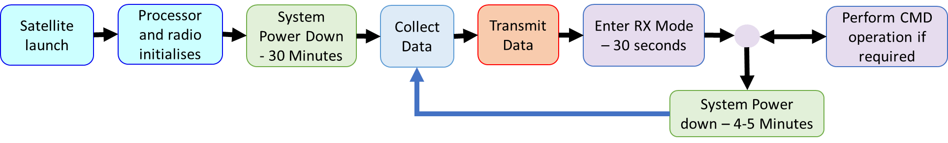

Figure 4 - Satellite radio beacon software cycle

The development of the software program for the satellite radio beacon is based upon the software cycle shown above in Figure 4. The validation process of the software cycle discovered that a small number of packets were not being received by a second LoRa module (The transmission of the radio packet was verified using an RTL-SDR[20] USB dongle driven by the Gqrx SDR[21] receiver software) with further investigation into this being carried out during the testing of the communications link. The receive function of the beacon software cycle was tested successfully with the radio beacon able to receive and execute a command. The APM module required 6 pins to be utilised (not including power, ground or connections for gathering telemetry data) for the successful operation of the developed satellite radio beacon software cycle.

Table 3 - Beacon total current consumption utilising different voltage regulators



The results for the regulator testing is detailed above in Table 3 and reveal that the LM1086[22] and TS2940CZ[23] LDO regulators have a much higher current consumption than the MC5205[24] LDO regulator and LM3671[25] Step-Down DC-DC converter (buck converter) during all phases of the software cycle. The inbuilt regulator and buck converter have similar quiescent currents throughout the software cycle except for during the *transmit* phase in which the LM3671 buck converter consumes 27mA less current.

Table 4 - Total current consumption measurements of the satellite radio beacon



The total current consumption of the satellite radio beacon for each phase is summarized on the previous page in Table 4 with tests showing that a single solar panel could not support the beacon operation if the TX power level was set above 10dBm without using an additional energy source. When 11mF of electrolytic capacitance was used as a supplementary energy supply to support the *transmit* phase then the radio beacon could be operated up to the maximum TX power (23dBm) when connected to one solar panel.

If the electrolytic capacitors are replaced with a single 5.5V,1F super-capacitor then the beacon system can be supported through all phases of the software cycle but a delay to the start of the software cycle is introduced. If a single super-capacitor is used, there is a 1-minute delay between when the solar panel starts to generate electrical power until there is enough energy to power all the sub-systems (2.6V potential) which increases to 8 minute and 20 seconds if the number of super-capacitors is increased to 5. The super-capacitor storage system reaches it full electrical potential after 27 minutes when the software cycle is 19 minutes into the *launch* phase. The average potential of the super-capacitor storage system after a one charging cycle was 6.3V which equates to 101 Joules of stored energy. The super-capacitor storage system, when fully charged, can support 1 hour and 14 minutes of beacon operations when no electrical power is being generated by the solar panel.

### **Discussion**

The results of the investigation into the minimization of the current consumption of the satellite radio beacon has shown that the beacon is self-sustaining and can operate independent of all other satellite systems. The testing carried out found the following methods to minimize the total current consumption of the beacon system:

* Place the ATMEGA328P processor into *powerDown* or *powerSave* low power modes where possible and remove all superfluous components
* Place the LoRa radio into *sleep* mode where possible and reduce the length of the *receive* and *transmit* phase to the shortest time required
* Reduce the radio transmission power to as low as possible
* decrease the size of radio packets to the smallest size to transfer data
* Utilize a more efficient voltage regulator, LM3671 Buck converter

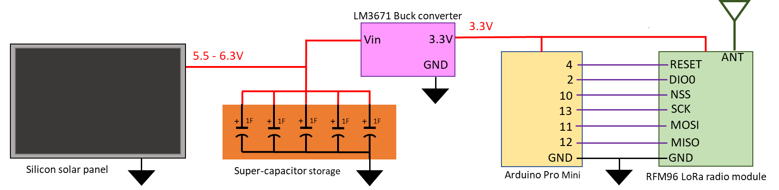

Figure 5 - Satellite beacon system configuration and connections for ground testing

One solar panel could not sustain operation of the beacon system without using an electrical storage system to support the spike in current consumed during the beacons *transmit* phase. The energy required to sustain a radio transmission was greater than the energy that could be supplied by one silicon solar panel. This led to the design of an energy storage system using five 1F super-capacitors that can support the maximum transmission power with one solar panel and can meet the no power to be stored requirements of the launch providers[26]. The storage system allows for 73 minutes of beacon operation when no power is being generated in low irradiance conditions and minimizes the space requirements of the satellite beacon by reducing the number of solar panels. The final design for the breadboard-based satellite radio beacon prototype is shown above in Figure 5.

The software cycle developed was based upon the software flow presented in Figure 4 on page 6 which must include a 30-minute period of radio silence immediately after release from the launch vehicle to meet the requirements of the launch provider (the delay caused by the super-capacitors can be included in this period). The radio beacon must have the ability to accept a command to silence the radio transmissions to meet the RF spectrum requirements[27] set by the ACMA and ITU which dictates that the software cycle must contain a receivephase. The communication link testing is required to be conducted to determine the LoRa radio settings and the format of the radio packet data before the satellite radio beacon software code could be finalized.

The connections to the APM module required to operate the beacon are shown above in Figure 5 which allows for a combination of analogue, digital and serial connections to other satellite systems to collect telemetry data. The basic software program uses 28% of flash memory and 50% of SRAM with 22k bytes of flash memory, 1k bytes of SRAM and 1k bytes of EEPROM remaining for use in the telemetry collection programming.

A waterfall design approach for the development of the satellite radio beacon system led to each component of the system being researched, designed and tested to ensure the beacon is self-sustained and independent from all other satellite systems. The beacon system can be constructed using a solderless breadboard with the final software configuration to be determined after the communication link testing.

## Communications Link

The communications link between the satellite radio beacon and ground receiving station must be able to sustain the reliable transfer of data for the expected slant range for a satellite in LEO. The orbital parameters for the missions in the LEO environment determine that the maximum distance to be supported by the data link is 2000kms which equates to a signal free-space path loss of 151.3dB. The TX power and radio configuration settings of the LoRa module will be determined based on the results of the link budget calculations.

### **Materials and Methods**

The first set of tests to be carried out for the communication link is to investigate the dropped radio packets that was found during the software testing and determine if there are methods to mitigate these losses. A detailed description of the methods used to carry out the testing is found in Appendix G with the tests first determining if changing the settings of the LoRa radio module or test conditions affects the number of packets dropped, which is known as the Packet Error Rate (PER). Secondly, a set of tests were conducted to analyze the presence of bit errors in the transferred data. The final set of tests utilized functions within the *RHGenericDriver* and *RH_RF95* files used in the RadioHead library that monitor the quality of transmitted and received data packets.

The next step in the communication link testing is to determine the radio settings that will allow the transmission of data to a satellite in LEO. The first step was to calculate the receiver sensitivity and link budget for the default and long-range radio settings available in the RadioHead library and compare against the values from the LoRa modem calculator tool available from Semtech[28]. A transmitter and receiver LoRa module were then connected with a series of cables and attenuators which simulate the Free Space Path Loss (FSPL) to verify the results of the calculations and determine the reliability of the transfer of data for the distance expected in an LEO mission. The methods used for testing and the results is detailed in Appendix G with the results and current RF regulations used to determine the radio settings and TX power that will be used for the final system testing.

The final step in the testing of the communications link is to perform all the necessary calculations to determine the link budget and compare against the estimates of the LoRa modem calculator tool. The method in which the communications link budget was calculated is detailed in Appendix H with the results of the link budget determining the TX power level and radio settings selected for LoRa radio module during the prototype testing.

### **Results**

The investigation into the radio parameters and test settings show that the two settings that record a reduction in dropped packets is the Cyclic Redundancy Check (CRC) setting and the coding rate. If the CRC is turned on, then the number of packets dropped can be reduced by up to 50% and if the number of CRC check bits are increased from 1 to 4 then up to 75% reduction in dropped packets was observed. This reduction in the number of dropped packets is not observed consistently using the different testing parameters and as such is a general observation with no trend being identified. There was a total of 8 tests carried out that analyzed the content of each byte which found that there were no bit errors present in 79,904 bytes received. Using the functions within the *RHGenericDriver* file revealed that the reason for the LoRa data packets not being received cannot be determined. There were a total of 85 packets dropped when the CRC was on with 79 being determined to have errors and 6 not received at all and there were 12 packets dropped when CRC was turned off with 3 packets determined to have errors and 9 not received at all.

Table 5 - RadioHead Library default LoRa module settings with LoRa calculator bit rate and receiver sensitivity estimates



A summary of the RFM96 LoRa radio module configuration from the RadioHead library default settings with a bit rate and receiver sensitivity estimate from the LoRa modem calculator tool is presented above in Table 5. The results indicate that the (2) default settings could operate over a longer distance using a smaller portion of the radio spectrum and has a comparable bit rate to the (3) default settings.

Table 6 - LoRa calculator Link Budget estimates and testing measurements for the RadioHead default settings



Table 7 - LoRa calculator transmission time estimates and testing measurements for the RadioHead default settings



The results presented in Table 6 (previous page) and Table 7 (above) compare the estimated values from the LoRa calculator against the measured values obtained from the testing. The results indicate that the LoRa calculator link budget estimates are a fair representation of the measured results, while the transmission times were slightly unreliable. The results from testing the communications link are shown below in Table 8 and reveal that the (2) radio settings can sustain a communication link for a larger distance (1dB greater FSPL attenuation) for a smaller transmit time (40% less Time-on-Air) than the (3) settings. The results from the testing also indicated an approximate 20% increase in bit energy when comparing the (2) settings against the (3) settings.

Table 8 - Link budget calculations for the satellite beacon to ground station communications link



A summary of the link budget calculations is presented above in Table 8 which shows that the communication link for the LoRa radio module has a positive bit energy to noise density ratio () when using both long range settings in the RadioHead library. A ratio above 10 maintains a reliable communications link which is achieved by setting the TX power to 15dBm or above for both RadioHead default long range settings.

### **Discussion**

The investigation to determine if the number of packets dropped can be reduced could not provide a set of radio parameters or test conditions that produce consistent results. The testing showed a small portion of the packets not received were rejected by the LoRa module (payload/header CRC check errors, checksum errors, bad lengths, etc.) with the rest not being received by the module at all (no preamble detection). Further investigation into the settings for the LoRa radio module was conducted that allows the data that is received by the module to be passed to the Arduino module for processing regardless of any errors present which found that the proprietary nature of the SEMTECH software prevented any modification of the LoRa receive process.

The number of packets dropped by the LoRa module through the whole testing process was determined to be less than 1% of the number of packets transmitted. To prevent the loss of all data at the receiving station, the transmitted identification and telemetry data will be separated between several radio packets. The identification of each satellite is 16 bits (2 bytes) with each radio packet containing two sets of addresses preceded by a radio packet identifier (1 byte) for a total of 5 bytes. The packet will be repeated four times during each *transmit* phase of the radio beacon followed by one packet of 50 bytes containing the telemetry data. This transmission format was selected due to the inability of preventing radio packets from being dropped by the LoRa receiver and it reduces the probability of the satellite identification not being collected to 0.00001%.

The calculations for the communication link budget show a significant increase in the bit energy to noise () when using the long range settings from the RadioHead library with the (2) settings providing a higher ratio. The smaller bandwidth (31.5kHz) of the (2) settings results in roughly 20% higher energy per bit as opposed to the (3) settings (125kHz) while using a smaller portion of the RF spectrum. The maximum TX power levels of the LoRa module are well below the maximum level that can be transmitted on the 435-438MHz RF spectrum as stipulated by the ACMA amateur license conditions. This allows the radio to be used at its maximum TX power (23dBm) with the decision made to initially use a 15dBm TX power to balance the beacons electrical power requirements while maintaining an above 10. There are several losses (atmospheric, weather, scintillation, polarization, etc.) that are difficult to quantify that have not been included in the link budget calculations but there is tolerance in the ratio to compensate for their losses. The testing revealed that a LoRa module with the (2) default settings has less Time-On-Air, occupies a smaller bandwidth of the radio spectrum and has higher bit energy contributing to the decision that the (2) default settings will be used for all further testing.

The testing carried out on the communications link has determined that the RFM96 LoRa radio module operating at 437MHz can support a reliable data link between a satellite radio beacon in LEO and a ground receiving station. The LoRa module uses the default (2) setting from the RadioHead library with a TX power of 15dBm to maintain a above 10 for a 2000km data link. The testing found that the PER of the LoRa module requires separate packets of data be sent to include a redundancy that ensures the satellite identification is received at the ground station during every *transmit* phase of the radio beacon cycle.

## Ground Receiving Station

It has been shown that the communication link can support the reliable transfer of data between the satellite beacon in LEO and an Earth-based station which leads to the design of the ground receiving station. The major constraint for the ground receiver is to produce a design using cost effective components that has an acceptable level of tolerance in determining the position of the satellite. The position of the satellite can be estimated using the time difference of arrival of the transmitted beacon radio signal at three ground stations which requires a common timing source between the stations and an accurate method of measuring time.

### **Materials and Methods**

The first design decision was to utilize the Global Navigation Satellite System (GNSS) in the ground receiving station to provide the geospatial location of the ground station, the Coordinated Universal Time (UTC) for a common timing source and a pulse per Second (PPS) signal for synchronizing the processor clock timing. The initial design of the ground receiving station will include a global positioning development module based on the U-Blox NEO-7M[29] GNSS module as it has a positional accuracy of 2.5m, a PPS signal available on an external pin with a 30ns tolerance and can be connected to a 28dB GNSS Antenna for increased GNSS signal reception.

The second design decision was to utilize the RFM96 LoRa module on the same breakout board as used in the beacon prototype allowing the use of the same software and libraries to provide continuity between the two components of the system. The breakout board used in this design contains a SMA connector allowing for a simple 3.5dBi Helix antenna or a 12dBi Dipole antenna to be used for testing.

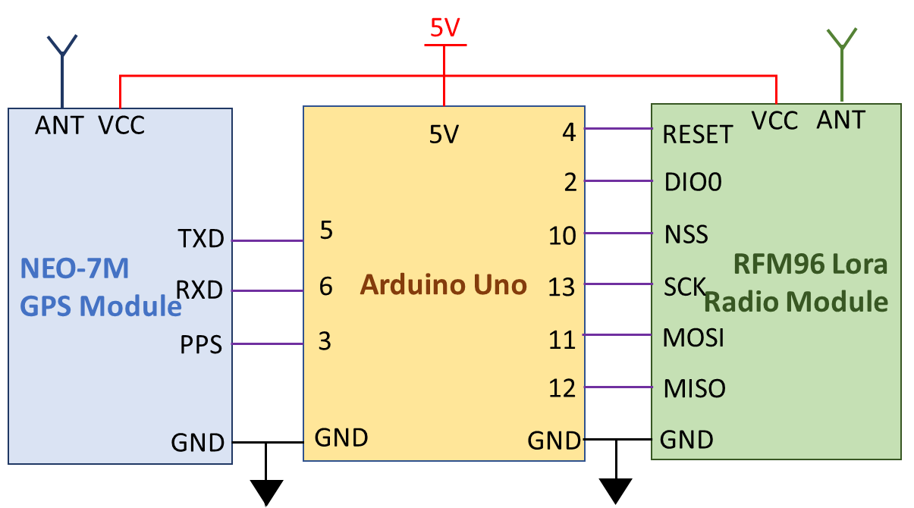The last design decision before development begins was to select the computer processor that will accurately measure time to a precision required for this application and can drive the LoRa and GNSS modules. The solutions were limited to an Arduino based MC board to ensure a processor was selected that is well resourced, has enough peripherals and is easy to use.This reduces the available solutions to the Arduino Uno or Arduino Due development boards. The Uno was selected for the initial design as the component cost was substantially less with it being noted that the Due processor speed (84MHz) is much higher than the Uno (16MHz) and could increase the precision of time measurement if required. The initial design of the ground receiving station is shown in Figure 6 (see right) with the total cost for the ground station being under AU$80.

Figure 6 - Satellite ground receiving station final design

After the initial design decisions were made, the next step was to develop the software code for the ground receiving station which is derived from the software flow chart detailed in Appendix I. The initial operation of the ground receiving station was planned such that as the ground station receives each packet (four identification and one telemetry radio packets) it produces a time stamp that marks the time of arrival referenced against the next GNSS PPS signal after the telemetry packet. The GNSS data is then captured which contains the current UTC time to a second precision and positional data of the ground station. The number of clock cycles between each packet time stamp and the PPS signal is used to determine the precise time of arrival of each radio packet with relation to the GNSS provided UTC. The timestamps, GNSS data (position and UTC), the identification data and the telemetry data are passed on to another device for further processing. The measured difference time of arrival, synchronization of GNSS UTC and known position of three ground receiving stations allows for the calculation of the estimated satellite position using a TDOA ranging technique.

The primary focus of testing the ground receiving station was to determine the possible sources of uncertainty in measurements that would determine the accuracy of the satellites estimated position. The initial research and testing of the system identified the following sources of uncertainty that could produce an error in the calculation of distance between the beacon and ground stations:

### The resolution of the Arduino built-in timer function, micros()

1. The number of clock cycles taken to carry out an Interrupt Service Routine (ISR)
2. Oscillator frequency drift due to temperature, tolerances and other sources of error
3. Tolerance of the GNSS PPS signal
4. Accuracy of the ground station GNSS position
5. The time taken for the LoRa module built-in software to carry out integrity checks (time between when the signal is received and when it is made available to the Arduino module)
6. The resolution of the ATMEGA328P processor clock cycles using an external oscillator

The detailed description of how each uncertainty in measurement was investigated and tested with results are presented in Appendix J. The results from the testing was combined to determine the total uncertainty in measurement between two ground stations with the final verification testing being carried out to verify the total uncertainty in measurement with the testing method and results shown in Appendix K.

### **Results**

The initial testing of the time measurement using the Arduino IDE software built-in function, *micros(),* reveled that the resolution of this measurement was found to be 4.096µs. The *micros()* function as implemented by Arduino has the output of the function being incremented only when the ATMEGA328P processor timer0 overflows resulting in the 4.096µs timing resolution which equates to distance calculation error of up to 1.23km.

The investigation into using the ATMEGA328P processor Timer1 to count the number of clock cycles between events revealed an uncertainty in the clock cycle count between successive events and the presence of a spike in the clock cycle count error (up to 190 clock cycles) occurring at irregular intervals. The results presented in Appendix J show that the difference in clock counts between uniformly timed events was less than 3 clock cycles for 97.3% of the measurements. When the spike in clock count errors were removed from the samples then the resultant statistics shows the uncertainty in clock cycles between events has a mean of 0.0266 and standard deviation of 1.1636 which results in 95% of the measurements being between -2.30 and 2.36 clock cycles.

The investigation into how the ISR were carried out revealed that the method for entering the routine for counting clock cycles (Timer1 ISR, *TIMER1_COMPA_vect*) and for the GNSS PPS pulse (External interrupt ISR, *INT1_vect*) are exactly the same and uses the same amount of clock cycles to enter, execute and leave an ISR. The method of using an the clock counting ISR or external interrupt ISR is common between each ground station and does not change the difference in time for the TDOA calculation.

The tolerances for the errors in the GNSS PPS signal (30ns) and the GNSS positional measurement of the ground station location (10m) were found to be acceptable as the uncertainties are much smaller than the uncertainty in measuring time and no further testing was carried out.

The testing of the time difference in processing of two LoRa modules shows that the processing time difference has a mean of -0.1803µs with a standard deviation of 2.7966µs. The cumulative distribution function of the measured samples was used to determine that 92.36% of the measured values lie between ±5µs.

Table 9 - Final verification testing total error in timing measurement between 2 ground station measurements



The results of the final verification testing are summarized above in Table 9 and show that the total absolute uncertainty in timing measurement has a mean of 380µs with a standard deviation of 520µs for the address packets and a mean of 419µs with a standard deviation of 634µs for the telemetry packet. This equates to 95% of the absolute measurement uncertainty of the address packets being less than 1.5ms and 95% of the telemetry uncertainty being less than 1.7ms which equate to a distance calculation error of 450km and 510km, respectively. If the absolute uncertainty in timing measurement is averaged between all five packets, then the mean is 395µs with a standard deviation of 150.2µs and 95% of the measured values below 0.9ms which is a distance calculation error of 270kms.

### **Discussion**

The investigation into a method that would reduce the level of uncertainty utilizes the counter of the Timer1 clock cycles in the ATMEGA328P processor which has a resolution of 62.5ns. The testing carried out determined that there was a tolerance of ±3 clock cycles with 97% confidence when using the clock counting method which equates to an uncertainty of 56.5m when calculating distance. When 4 PPS signals are averaged to determine the instantaneous oscillator frequency then the uncertainty increases to ±4 clock cycles. This results in a very small tolerance in the length of clock cycle calculation (less than 2fs) and can be disregarded in the distance calculation uncertainty. The tolerance of the GNSS PPS signal is 30ns (distance calculation uncertainty of 9m) and the tolerance of the GNSS position is 10m which results in a total distance uncertainty of 19ms for the GNSS modules. The largest uncertainty is from the difference in processing time between two LoRa modules to process the same received radio packet and make it available to the Arduino module which was determined to be 5µs (with 92.6% confidence) which equates to an error in the distance calculation of 1.5km.

The results of investigating the error in timing measurements indicated that each ground station will have a total distance calculation uncertainty of 75m for the GNSS and Arduino module with the LoRa module introducing a 1.5km uncertainty for the difference in the LoRa processing times. The total expected error in distance calculations between two ground receiving stations is 1.575kms which equals a time measuring uncertainty of 5.25µs. The verification testing carried out between two ground stations shows the total uncertainty in timing measurements to be between 1.5-1.7ms which equates to a distance calculation error of 450-510kms.

The initial investigation for the large uncertainty in timing measurement tested the two external interrupts (the GNSS PPS signal and LoRa module *RXDone* interrupt) with the PPS signal found to be within tolerance while the LoRa module was found to have a processing time difference of up to 30µs (most were between 5-15µs) which is 25µs greater that then the values found during previous testing. This increase of the LoRa processing time is equal to a distance calculation error of 9km which is much less than the error found in the verification testing. The large spike in clock counting error found during testing of the clock cycle counting algorithm was never greater than 190 cycles which is equal to on uncertainty of 12µs or a distance calculation error of 3.5km which is much less than the final testing error but gives an indication to the cause of the error. The determined cause of the spike in the clock counting test was found to be due to the time taken (and number clock cycles) for the program to finish executing the current set of instructions before it enters the interrupt routines. The increased complexity of the ground receiver software and the two external interrupts used in the program taking precedence over the clock counting ISR causes a large increase in the number of clock cycles occurring before the Timer1 overflow count updates. To determine the reason for the large increase in error in counting clock cycles (1.5ms is equal to 24,000 clock cycles), an investigation into the method of implementing and calculating the clock cycles between events for the ground receiver station will be required with a focus on using timer capture modes for the ISR. This investigation to reduce the final error in timing measurement will be required to be carried out before the data acquired by the ground receiving station can be used reliably in calculating the estimated position of the satellite.

# Conclusions

The aim of this project was to produce an initial prototype design for a self-contained and independent radio beacon that can transfer satellite identification and telemetry data from a small satellite in a low earth orbit to a ground receiving station. The project was extended to include a tracking function which uses the radio beacon signals time of arrival at multiple dispersed ground stations to estimate the position of the satellite using the TDOA trilateration calculation technique. The design of the satellite beacon prototype is presented on page 7 in Figure 5 and was the first step of the process with a focus on ensuring the beacon is self-sufficient, independent and the size of the beacon is minimized. The initial beacon prototype was designed, tested and verified to be capable of: 1) operating without an input from other satellite systems, 2) collecting telemetry data from other satellite systems, 3) sustaining normal beacon operation using a single silicon solar panel, and 4) executing a command transmitted from a ground station. The next step in the design process was to verify the LoRa radio modules could support the transmission of data over a communications link from a satellite in low earth orbit to a ground receiving station. The calculation of the communications link budget was supported by the tests conducted which show that the reliable transmission of data can be supported by the LoRa radio modules for slant range distances up to 2000kms. The data transmitted by the satellite beacon system contains a 16-Bit identification address in four identifiable, sequential radio packets followed by the satellite telemetry information in a separate radio packet. The information was split into separate radio packets to ensure that the satellite identification is received due to the high PER of the LoRa module. The final step was the design of the ground receiving station which is shown on page 10 in Figure 3, with the initial ground tests showing that it is capable of receiving the satellite identification and telemetry data. The testing of the satellites radio beacon signals time of arrival between two ground stations indicated an uncertainty of 5µs in the time measurement which equates to a distance calculation error of 1.5kms. The final verification testing carried out using the developed ground station software demonstrated that the time of arrival data collected by two ground stations has a measured time uncertainty of 1.7ms which is a distance calculation error of 510kms. The amount of uncertainty in calculating the distance of the satellite from the ground receiving station is too large for this application with further work required to produce a more accurate time measurement technique in the ground stations. The concept of the small satellite radio beacon system has been proven for satellite identification, telemetry and control capabilities but the ground receiving station requires additional work to develop a reliable and accurate tracking function.

# Recommendations

To conclude the initial design of the ground receiving station and ensure the satellite beacon system has a tracking capability requires further study to reduce the level of uncertainty in the received signals time of arrival between two ground stations. The uncertainty in time measurement by the ground station should be the focus of the investigation with the most likely contribution to uncertainty being found in the current ground station software program. The reduction of the uncertainty in time measurement to an acceptable level will allow for the development and verification of tracking the satellites position by using the time difference of arrival at multiple ground stations. This will then lead to the developing a TDOA algorithm that calculates the estimated position of the satellite within the determined uncertainties using the collected TDOA values and the latitude and longitude position of the ground stations. If the tracking capability is verified the development can continue to design a computer server system to transfer the required data between globally dispersed locations and develop a graphical user interface for displaying the position of the satellite.

The next step in the development of the satellite radio beacon is further investigation into the electrical components utilised in the prototype to ensure it is capable of operation in a space environment. Once the electrical components have been selected then a printed circuit board (PCB) design for the radio beacon can be developed to enable the execution of the recommended ground testing before space operations[30].

# Acknowledgements

Firstly, I would like to say thank you to my wife, Christine and children for their unquestionable love and support throughout my studies and particularly through this research project. I would not have been able to complete my study without the time, support and understanding that they have provided through some demanding times.

I extend my sincerest gratitude to my thesis supervisors, Dr Edwin Peters and Dr Craig Benson, for their guidance and support through the project learning process The brainstorming provided by Dr Craig Benson help to creatively shape the concept, which could only be transformed to reality with the time, dedication, knowledge and experience provided by Dr Edwin Peters.

This document would not exist without guidance and advice from Bianca Mister-Colmenares of the UNINSW Canberra ALL unit. I want to recognize the time, effort, expert knowledge and literary artistry she has provided to improve the presentation of this document and develop my writing skills.

I wish to extend my appreciation to Darryl Budarick of the Technology Support Group at UNINSW Canberra for the guidance, support and feedback in developing the hardware for this project.

The expert guidance from Lisa Conti Phillipps of the UNINSW Canberra Library has taught me how to perform effective research and saved me many hours of unnecessary searching for which I am thankful.

# References

1. PLTOFF, School of Engineering & Information Technology. ZEIT4501 & ZEIT4297.
2. DELPOZZO, S., WILLIAMS, C. & DONCASTER, B. 2018. 2019 Nano/Microsatellite Market Forecast. 9.
3. WEKERLE, T., PESSOA FILHO, J. B., COSTA, L. E. V. L. D. & TRABASSO, L. G. 2017. Status and Trends of Smallsats and Their Launch Vehicles An Up-to-date Review. *Journal of Aerospace Technology and Management,* 9**,** 269-286.
4. VENTURINI, C. C. 2017. Improving mission success of CubeSats.
5. KELSO, T. S. 2017. Challenges identifying newly launched objects. *Proceedings of the International Astronautical Congress, IAC,* 6**,** 3898-3903.
6. PHAN, S. 2019. SRI International’s CubeSat Identification Tag (CUBIT): System Architecture and Test Results from Two On-Orbit Demonstrations.
7. SVITEK, T. 2018. Passive RF Tag for Satellite Tracking. Available: <https://static1.squarespace.com/static/5c54e307fd67934e24b27846/t/5ca42cece5e5f0302a31f91c/1554263277115/RF+tag+white+paper+2018+02+01+public+release.pdf> (Accessed 07 oct 2019).
8. PALMER, D. M. & HOLMES, R. M. 2018. Extremely Low Resource Optical Identifier: A License Plate for Your Satellite. *Journal of spacecraft and rockets,* 55**,** 1014-1023.
9. CIALONE, G., MARZIOLI, P., MASILLO, S., GIANFERMO, A., FREZZA, L., PELLEGRINO, A., PIERGENTILI, F. & SANTONI, F. LEDSAT: A LED-Based CubeSat for optical orbit determination methodologies improvement. 5th IEEE International Workshop on Metrology for AeroSpace, MetroAeroSpace 2018 - Proceedings, 2018. 456-461.
10. LINHART, R. 2013. Safety radio beacon for the PilsenCUBE satellite. *Applied Electronics, AE, International Conference on*.
11. RIVERS, T. D., HESKETT, J. & VILLA, M. 2015. RILDOS: A Beaconing Standard for Small Satellite Identification and Situational Awareness.
12. HUMAD, Y. A. I., TAGELSIR, A. & DAFFALLA, M. M. 2017. Design and implementation of communication subsystem for ISRASAT1 Cube Satellite. 1-4.
13. POPESCU, O. 2017. Power Budgets for CubeSat Radios to Support Ground Communications and Inter-Satellite Links. *Ieee Access,* 5**,** 12618-12625.
14. Atmel corporation, “8-bit AVR© Microcontroller with 4/8/16/32K bytes In-System Programmable Flash”, ATMEGA328P datasheet, 2009
15. HopeRF Electronics, “RFM95/96/97/98(W) - Low Power Long Range Transceiver Module”, RFM95/96/97/98(W) datasheet, 2019
16. GitHub. 2020. *Attexx/Rfm9x_Breakout_Board*. [online] Available at: https://github.com/attexx/rfm9x_breakout_board (Accessed 16 Feb 2020)
17. Seeed Studio, “0.5W Solar Panel 55x70”, 0.5W solar panel description, [online] Available at: <https://www.seeedstudio.com/0-5W-Solar-Panel-55x70.html> (Accessed 10 May 2020)
18. 2020. *Arduino IDE*. Arduino LLC. Available at: <https://www.arduino.cc/en/Main/Software> (Accessed: 13 Jan 2020).
19. Airspayce.com. 2020. *Radiohead: RH_RF95 Class Reference*. [online] Available at: https://www.airspayce.com/mikem/arduino/RadioHead/classRH__RF95.html (Accessed 09 Feb 2020).
20. RTL-SDR, “RTL-SDR Blog V3 Datasheet”, RTL-SDR datasheet, 2019
21. Csete, A., 2020. *Gqrx SDR*. Alexandru Csete OZ9AEC.
22. Texas Instruments, “LM1086 1.5-A Low Dropout Positive Voltage Regulators”, LM1086 datasheet, June 2000 [Revised Apr 2015]
23. TSC Electronics Ltd, “TS2940 1A Ultra Low Dropout Fixed Positive Voltage Regulator”, TS2940CZ datasheet, 2003 [Revised 2012]
24. Microchip Technology Inc, “MC5205 150 mA Low-Noise LDO Regulator”, MC5205 datasheet, 2017
25. Texas Instruments, “LM3671/-Q1 2-MHz, 600-mA Step-Down DC-DC Converter”, LM3671 datasheet, Nov 2004 [Revised May 2016]
26. INITIATIVE, N. C. L. 2017. NASA CubeSat 101: Basic Concepts and Processes for First-Time CubeSat Developers. *NASA CubeSat Launch Initiative*.
27. AUSTRALIAN COMMUNICATIONS AND MEDIA AUTHORITY (2020). *Radiocommunications Licence Conditions (Amateur Licence) Determination 2015*. Available at: <https://libguides.ioe.ac.uk/c.php?g=482485&p=3299865> (Accessed: 14 May 2020).
28. 2019, LoRa Modem Calculator Tool, Semtech Corporation. [online] Available at: <https://semtech.my.salesforce.com/sfc/p/#E0000000JelG/a/2R000000HUhK/6T9Vdb3_ldnElA8drIbPYjs1wBbhlWUXej8ZMXtZXOM> (Accessed 29 Oct 2019)
29. U-Blox, “NEO-7 u-blox 7 GNSS modules”, NEO-7M datasheet, Nov 2014
30. INITIATIVE, N. C. L. 2017. NASA CubeSat 101: Basic Concepts and Processes for First-Time CubeSat Developers. *NASA CubeSat Launch Initiative*.